***Project Phase III Report***

***On­­­***

**T.O.P. (Transport Optimization Program)**

**Submitted for the requirement of**

**Project course**

BACHELOR OF ENGINEERING

**COMPUTER SCIENCE & ENGINEERING**



**Submitted to: Submitted By:**

**Project Teacher(Supervisor) Harshit Gupta 20BCS4925**

**ROHINI BAWA (E12228) KinshukChauhan 20BCS4917**

**AnkulAgnihotri 20BCS4913**

**Ashutosh Kumar 20BCS4960**

**SohailIqrar 20BCS7814**



**Co Supervisor Signature**

**GURSIMRAN KAUR (E7544)**

**DEPARTMENT OF COMPUTER SCIENCE & ENGINEERING**

**CHANDIGARH UNIVERSITY, GHARUAN**

**June 2022**

### 

**ABSTRACT**

TOP [Transport optimization program]'s main purpose is to optimize the transportation system. Optimization includes the method to use resources efficiently like transportation system so that it saves time and even makes it available on time for passengers and also to reduce pollution, and conserve energy. Sharing of the vehicle is Vehicle pooling so that multiple numbers of people can travel in a single-vehicle. the use of vehicle pooling reduces single individuals Travelling costs, reduces the fuel cost, and reduces the number of vehicles. Due to the growth in the population, there is inadequate transportation through their vehicle. Rather than using a different mode of Transportation. It results in an increasing number of traffic on roads also increases pollution and increases the time to travel to their destination. So by Smart transportation using a vehicle pooling system the individual can travel and share their rides with different people of the same destination. In this paper, we have carried out a survey. Reviewing various Literature papers on carpooling it aims to reduce the number of vehicles by sharing the rides. Electric taxis have the potential to improve urban air quality and save drivers’ energy expenditure. Consequently, the running cost of EVs comes to Rs 1 per km, Rs 9 for petrol, Rs 6 for diesel, and about Rs 2.5 per km for vehicles being run on CNG. Although 3 battery electric vehicles (BEVs) have drawbacks such as the limited range and charging inconvenience, 4 technological progress has been presenting the promising potential for electric taxis Its website and mobile apps connect drivers and passengers willing to travel together between cities and share the cost of the journey. The company does not own any vehicles; it is a broker and receives a commission (between 18% and 21%) from every booking. In this era of technology, everything is getting combined with technology to perform or transform for the better so we will be using technology to make an effort to solve this problem. We will be building a website that will be a platform that will connect the passengers with the traveling mode

**TABLE OF CONTENT**

|  |  |  |  |  |  |  |  |  |  |  |  |  |  |  |  |  |  |  |
| --- | --- | --- | --- | --- | --- | --- | --- | --- | --- | --- | --- | --- | --- | --- | --- | --- | --- | --- |
|  | | |  |  |  | | --- | --- | --- | | **S.NO.** | **CONTENT** | **PAGE NO.** | | 1. | Feature/characteristics identification | 4 | | 2. | Constraints Identification | 6 | | 3. | Analysis of features and finalization subject to constraints | 7 | | 4. | Design selection | 8 | |  |
|  | |  |  |
|  |  | |  |

**Feature/Characteristics Identification**

Our project, based upon Web Application about future of transportation with random people(carpooling). In this there is serious reduction of number of vehicles on the road which leads to lessen the effects of emission of pollution related gases carbon dioxide, monoxide just to name a few.

Characteristics of the Project: This project is going to be distinctive in various ways than other projects in the following ways:

1. **Objectives –** The main objective of this project is to create a platform to solve major environmental issues and to provide customers with optimized facilities. This is going to prove a good approach to resolving the issues related to costly cab booking and also save the time of the customers. This will also have several good effects like a better use of resources and a reduction in time incompatibility.

1. **Single entity –** Our team is working on various models and we will implement it together to create a single entity, i.e., to create a website to make travel wonderful.
2. **Life Span –** Our project is a long-time goal however it’s time-bounded. We started work on this project two month ago and expected it to complete it within 6 months according to the advice given by our co-supervisor. Within this time frame our team is divided according to the modules they are developing, our team is divided into three modules, the total time span of the project is 6 months, our first module was set to complete within 2 months, which has already completed within 1.5 months, our second and third module are also expected to complete within 2 months individually.
3. **Require funds –** Our plan is to work cost-efficiently and already have estimated the cost of our project, our project doesn’t require any big fund as of now but in future we may require funding to hire and expand our team to take this project to bigger height. As our demands and network will grow, we will be needing more and more number of vehicles in order for us to serve everyone needing our services and that will require a huge amount of fund.

1. **Life Cycle –** Our project is working on the principle of API and Artificial Intelligence, this project has various phases such as planning, analysis, designing, implementation, testing and integration and then maintenance. We have already done the planning and analysis; we are working on the designing part.

1. **Team Spirit –** Our team spirit is very high because our project constitutes of different members who are enthusiasts, having different characteristics and from various disciplines. Are able to achieve common goal harmony, missionary zeal, and within time limit.

1. **Risk and Uncertainty –** The project is generally based on forecasting. So, risks are the part of projects. There is a slight chance of risking the progress that we have done so far in the project. Only the degree of control over risk and uncertainty varies with the project being conceived based on modules we are working on.

1. **Directions –** Our project is according to the plan and is progressing in a positive direction which can be explained by the fact that our project is getting ready step by step before the estimated time set by us.

1. **Uniqueness –** Our project is unique in itself, and it’s having own features. The uniqueness of our project can be measured by considering many factors like our objectives which is to provide anyone the best way to travel to their destination, the features that we will be providing to our customers, reliability of the project, and application of the project.
2. **Flexibility –** We are working on our project in such a way that it’ll be completely flexible, our project can be modified according to the input and needs of the customer easily and without implementing any external module.

1. **Sub-Contracting –** Our project requires the guidance of supervisor and co-supervisor from time to time, our team also take advices from professors and experts in the field of AI and Web Application as well as Database Management System.

1. **Cost –** The quality of our project is not to be changed yet however there could be an impact on the cost of the project. The cost could increase if more resources are required to complete the project quicker.

**Constraints Identification**

There are six major constraints in project management to consider:

1. **Time:** The project’s completion time is 6 months, and is expected to get completed before 6 months.
2. **Cost:** The budget of the project is very less, which is expected as our project is cost-efficient and doesn’t require much funding.
3. **Scope:** Our project will provide the customer the estimated provide the best transport facility as per their needs.
4. **Quality:** We are trying to keep our website as optimized as possible, and our dataset as clean as possible to give the best results.
5. **Benefits:** The Application will reduce the time consumed to maintain manual records and is not tiresome and cumbersome to maintain the records. Hence operational feasibility is assured. Our application will reduce the time that is wasted in searching and getting bumped around.
6. **Risk:** This application will help customers to get their vehicle without approaching station or agent. It also decreases the risk involved in the transaction. However, there are other risks such as data leaks that can lead to problems.

**Analysis of Features And Finalization Subject To Constraints**

Due to the increasing amount of peoples, every single people travel to their Destination alone in their own car. Traveling alone leads to increases individual fuel costs. The carpooling system merges multiple new people in a car which leads to meeting new people in a car, reducing air pollution and noise pollution. The carpooling system saves the economy of every people as they share their rides and also share the cost with the other member in the car. It will stop endless Spending money on travel. Rather than using public transportation such as local trains, buses, and metros. People can conveniently travel to their destination comfortably by giving the same cost. Carpooling is the best idea to reduce traffic jams as it reduces the car on road. Safety is an important aspect in every means, so traveling with different people is also a prior thing not all people are comfortable traveling with unknown people. For example, women are not feeling safe traveling with unknown people. So the carpooling system also provides rides for only women.

Cities with a lack of efficient public transport infrastructure result in users depending on alternative modes of transport. This includes an increase in the use of private vehicles, which could lead to reduced traffic safety, further deterioration of air quality, and an increase in road congestion. Trade growth of goods and services and the upsurge in activities are generally high in cities of developing countries. Every city needs to enhance its transport infrastructure to cope with the increase in transportation demand. In addition, these transportation infrastructures need to be efficiently used in order to minimize costs and maximize output. Adopting sharing-based business models can help in increasing the trade of goods and services and can increase the number of activities.

**Design Selection**

1. **Application overview table:**

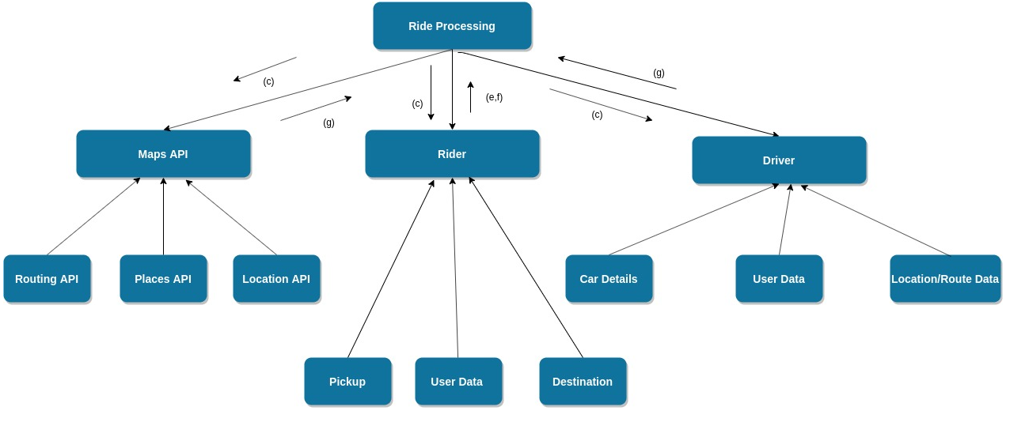

1. **Data flow diagram:**

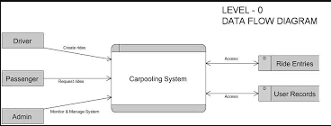

1. **Class Diagrams:**

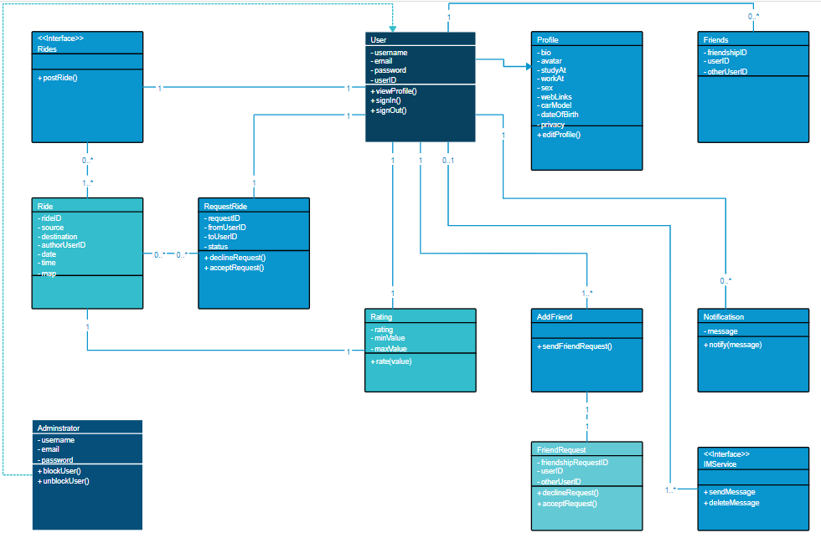

1. **Use Case Diagram:**

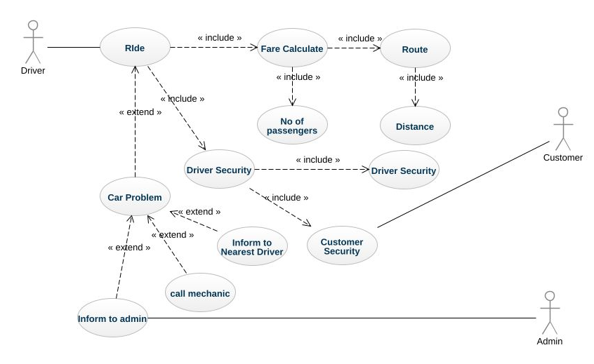

**\*\*\*\*\*\*\*\*\*\*\*\*\*\*\*THANKYOU\*\*\*\*\*\*\*\*\*\*\*\*\*\*\*\***